S&L:Travel Agent Role Play


Look at the pictures. What type of holiday do they show? Where do you think they are?



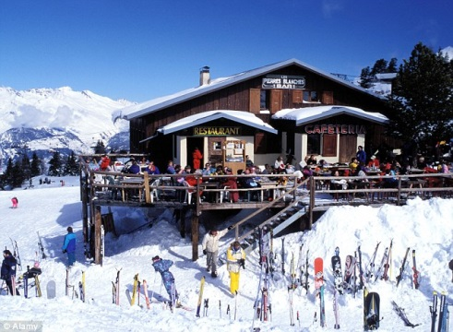


- Work with a partner and discuss. What is important to you when you go on holiday? Why? You can use the words in the box below to help you in your discussion.
Accommodation Catering Transfers Excursions
Price (value) Visas Weather Currency
Culture People Landmarks Child-friendly
Beach Atmosphere Sports
- You are going to read a dialogue between a travel agent (TA) and a customer (C). Work with a partner and practice the dialogue. Be prepared to read it in front of the class.
TA: Good morning Traveltime. How can I help you?
C: Oh Hello. Yes, I’m looking to book a holiday.
TA: Certainly, what type of holiday did you have in mind?
C: I’m interested in going to Argentina. Could you tell me more about that holiday?
TA: Well, it’s a 10 day trip to Buenos Aires, 3 star hotel. That’s £499 per person.
C: Flights are included in the price, are they?
TA: Return flights from Manchester airport are included.
C: Great. Could you tell me more about the hotel?
TA: It’s 45 minutes away from the airport and a 15 minute walk from the centre of the city.
C: That is close, isn’t it? What about transfers from the airport to the hotel?
TA: Bus transfers will cost an extra £20 per person.
C: I see. I would also like to know if meals are included.
TA: Actually, only breakfast is included at the hotel.
C: Right. Could you tell me about the excursions that are available?
TA: Sure. There’s a trip to La Boca – the colourful neighbourhood where Maradona started playing football and there is a chance to learn to dance the tango with professional dancers.
C: Sounds very interesting. And there is an extra charge for the excursions, is there?
TA: Yes, there is but you can pay that at the hotel.
C: Lovely. Do you know anything about the weather there this time of year?
TA: Well, it’s summer over there at the moment, so there’s plenty of sun.
C: That sounds lovely, doesn’t it? I think I’ll go for it.
- Look closely at the language used in the dialogue. Fill in the table below with appropriate examples from the dialogue
How can you…
Ask questions politely? | Indirect questions: Do you know anything about…  Could you tell me…
Check if you are not sure about something? | Question tags
Show interest? | Sounds very interesting.
Acknowledge what someone said? | Yes. Certainly. Right. I see. Sure. Great

- Role Play
Work in pairs. A and B.
- Look at the holiday advertisements on the walls in the classroom. Choose one holiday that you like. Think of 6 questions to ask the travel agent about this holiday. You can write the questions so you remember.
- You are a travel agent. The teacher will give you more information. Read it carefully, but don’t show it to your partner! Answer your partner’s questions. If you don’t know the information, think about what you can say.

We call these words at the end QUESTION TAGS.
Question tags are auxiliary verbs (be, have, do) and modals (should, can, might, will)
Question tags can be positive or negative.

Question tags

It’s a wonderful day, isn’t it?

It isn’t very warm, is it?

Fill in the information table below.

Use | Form | Intonation  Rising/falling | Example
To share an opinion.  To encourage others to respond. | Positive, negative  OR  Negative, positive | Falling | The weather’s awful, isn’t it?  That’s not right, is it?
To check something we’re not sure about | Negative, positive  OR  Positive, negative  OR  Positive, positive | Rising | You’re not from Somalia, are you?  You’ve finished it, haven’t you?  That’s it, is it?
To ask for help or information | Negative, positive | Rising | You couldn’t pass me the pen, could you?

Complete the following sentences with a QUESTION TAG.

- You said you liked my idea, ___________________?

- It’s very dangerous, ___________________?

- You can’t drive, _________________?

- That’s not fair, ________________?

- We should give him a ring, ________________?

- He will be upset, _________________?

- You couldn’t say that again, ____________________?

- She has moved to France, __________________?

